Agricultural Development Association(PARC)-Gaza

You cannot smile at all. You are in Beit Hanoun:
The human situation in Beit Hanoun village north of Gaza city
Sunday 5th Nov. 2006

Beit Hanoun is a crowded residential area. It is located a few kilometers to the north of Gaza city. It’s easy to reach there by car. It is also a few kilometers to the south of Sederot town in Israel. Historically speaking, in 1948 Sedrot was established on the remains and land of the Palestinian village of Semsem. It is worth noting that Beit Hanoun contains the Gaza Strip's most fertile land. Is that why it had to be wiped out? The World Bank has made approach and overtures to invest in the north of Gaza including Beit Hanoun in an attempt to improve and strengthen the Palestinian economy which has been totally devastated by the Israeli military incursions.
On Wednesday 1st Nov. 2006, the Israeli army with its highly sophisticated weapons and rich logistic support has started an attack on Beit Hanoun under the pretext of preventing militia men from launching the local-made rockets towards Sedrot. In few hours they tightened their siege on the village. We thought that the military activities are limited to time, place and against certain people as mentioned in the media, but the reality of the situation has proved that it is not only so. The military action has targeted everyone living in the village and every piece of cultivated land regardless of any consideration, and a real damage has been inflected upon the agricultural sector. Well, today is Sunday; it’s the fifth day of the ongoing Israeli military operation inside the border village of Beit Hanoun and around it. It is what the Israel army calls “Operation: Autumn Clouds.”

Up today, in Beit Hanoun and elsewhere in Gaza Strip a total of 48 men of different ages, and 2 women are killed and some 250 are injured with more than 50 people in serious and critical conditions in ICU of two hospitals in the area. This number includes those who were assassinated by attack of Israeli helicopters and jets launching missiles at their cars. Israeli officials declared their regret for killing innocent civilians in the operation. The Israeli chief of staff visited the troops in Beit Hanoun and expressed his admiration in their performance and gave praise to the leader of the operation as his units are looking for more weapon stores.

Moreover, after a military order by loudspeakers for the Palestinian men of the village to gather in a school yard, hundreds of the Palestinians between 16-60 years of age were rounded up and carried away in military trucks to an unknown destination; it could be to a concentration camp erected in the Negev desert to the east of Burij refugee camp in the middle area of Gaza Strip. Those detained men have been estimated as around 1500.

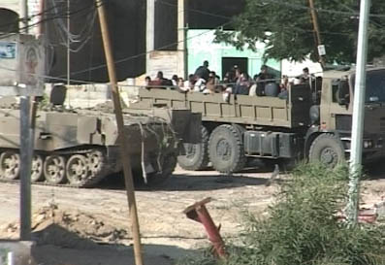

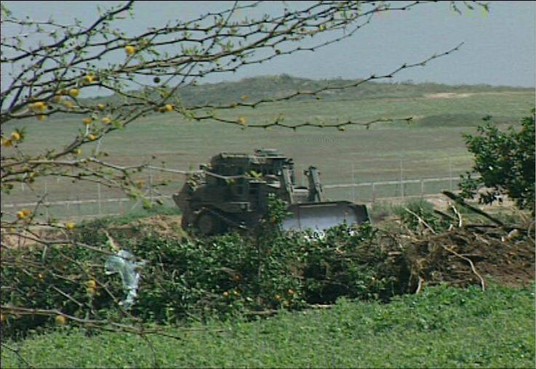
It is worth noting that the two women were killed while marching with dozens of other women in a passive resistance attempt to protest against the atrocities of the Israeli soldiers. Women were in need of a space to move around to get food and other daily life need. It seems that what we anticipate is not the proper frame of the military activities, and accordingly, little can be expected from any future attempts to remedy its ailments. In self-defense, the Israelis keep bringing back the Palestinian farmer to zero point, thus he has to start again! Israeli policies and activities represent a slap in the face of the Palestinian civil service organizations including the agricultural communities in particular. They destroy everything in sight. For 5 straight days so far, Beit Hanoun was deprived from too many things like electricity, telecommunications, food and medical supplies. Moreover, the operation is meant to destroy the agricultural lands, livestock and crops particularly that Beit Hanoun area is rich in producing and it also produces other crops such as the strawberry, citrus, flowers, and other plants. It seems that the Israeli intention is to level the agricultural sector in the area. This is lucid evidence that Israel practices a collective punishment. In simple words, what’s going on is an organized destruction of the human life of the Palestinian villagers and all the supportive efforts and investments.

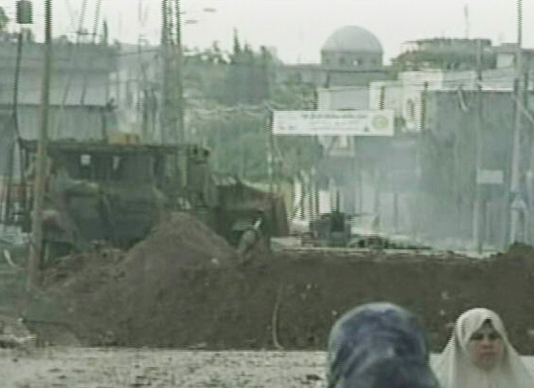

As from the first day of the offense , a curfew was imposed on the village and the surrounding agricultural areas so as to secure movement of the army vehicles and tanks. Army bulldozers took a main part in the operation. Under cover from tanks and helicopters, the bulldozers uprooted trees and destroyed crops in hundreds of acres of land under different pretexts such as opening new roads for their military campaign and creating empty areas so as to prevent launching the local made missiles against Israel. Well, after five days those missiles are still launched and the vast military campaign did not stop them or change anything in their equation. The Israeli soldiers are conducting home to home search going into everywhere they could and search for arms and men. The search does not go smoothly, but rather it is embedded with harshness and harassment against the children and women who are supposed to have remained at home.

On the fourth day of the offensive, the Israeli army left the curfew for a couple of hours so as to give a chance for women only to move around for getting the necessary and basic life needs such as milk for the children and flour for making local made bread and the like. No shops or groceries are open so that women resort to their neighbors and other relatives in the same neighborhood seeking help with what could be extra food stuff or whatever needed and still available with some!

With this new situation, the people of Beit Hanoun have been stuck between a stone and a hard rock. They lost wide areas of cultivated land; their plants, tress and greenhouses have been intentionally targeted. Accordingly, there is no wonder that their agricultural land and their economy are still going down with everyday the offensive continues. Worse is that those government employees have not received except some 20% of their salaries for seven month so far, let alone the high employment rate in the area. All those factors are destructive to the economic, social, and cultural issues of the village. Then, the incursion has added salt to the injury; the military operation has worsened the human situation and took it form bad to worse. In simple words, the people have lost hope in almost everything around them and their children are really starving. They have been deprived of the basic need of normal life. Children have been terrified by shooting, shelling, explosions, and blasts. The current military operations have worsened the human situation to the extreme. It’s taking the whole area form bad to worse. Two days back UNRWA was permitted to go into Beit Hanoun but it is still that people are hungry and starving and death is taking its toll.

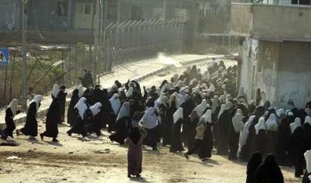
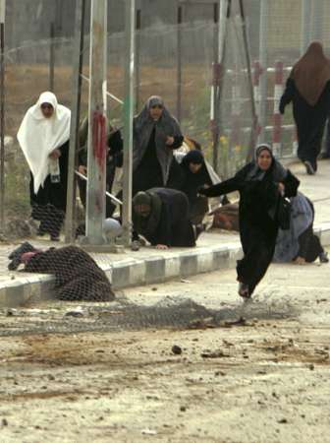

Those two photos can speak for themselves. A moment of peaceful demonstration and protest has turned into a moment of death for two civilian women and injuries for others! Protestors were calling upon the Arab leaders and the world community to intervene to stop the Israeli operation. Just imagine the situation.

------------------------------------------------------------------------------------------------------------------------------------
Cooperation & External Relations Department.
Agricultural Development Association (PARC)-Gaza
Tel: +972 (or 970) 8 2805042
Fax: + 972 (or 970) 8 2805039
e-mail: adming@palnet.com
www.pal-arc.org

